DBS311A Lab 7

1.

DECLARE

d_name department.department_name%type;

d_location department.location_id%type;

CURSOR d_cursor(find VARCHAR)

IS

SELECT department_name, location_id FROM department WHERE department_name LIKE find||'%';

BEGIN

OPEN d_cursor('Z');

LOOP

FETCH d_cursor INTO d_name, d_location;

IF(d_cursor%ROWCOUNT = 0)

THEN

dbms_output.put_line('No department starts with the letter Z');

END IF;

EXIT WHEN d_cursor%notfound;

dbms_output.put_line(d_name || ' in location ' || d_location);

END LOOP;

CLOSE d_cursor;

END;

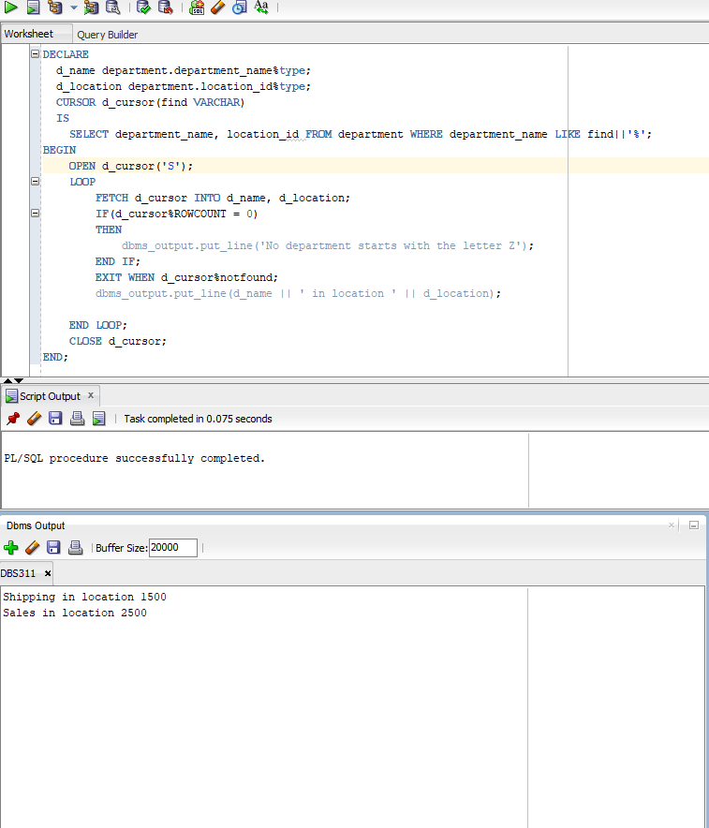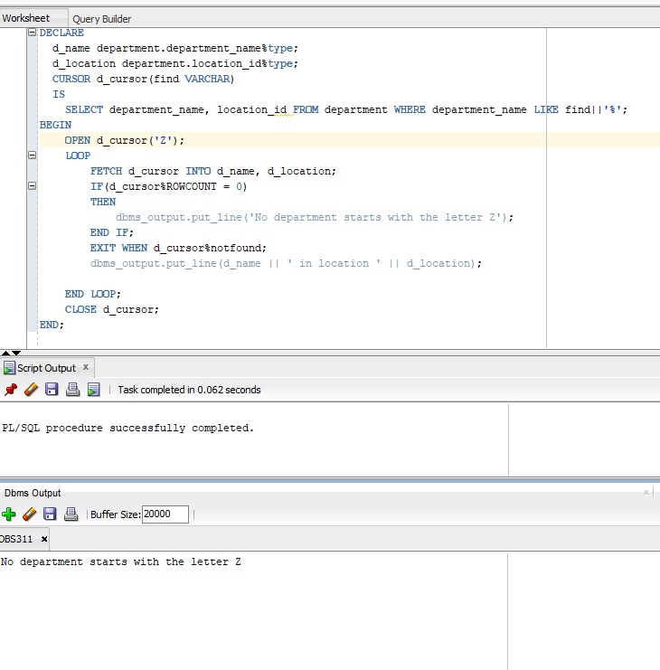

2.

DECLARE

isFound boolean :=false;

CURSOR d_cursor(find VARCHAR)

IS

SELECT department_name, location_id FROM department WHERE department_name LIKE find||'%';

BEGIN

FOR department IN d_cursor('S')

LOOP

isFound:=true;

dbms_output.put_line(department.department_name || ' in location ' || department.location_id);

END LOOP;

IF NOT(isFound)

THEN

dbms_output.put_line('No department starts with the letter Z');

END IF;

END;

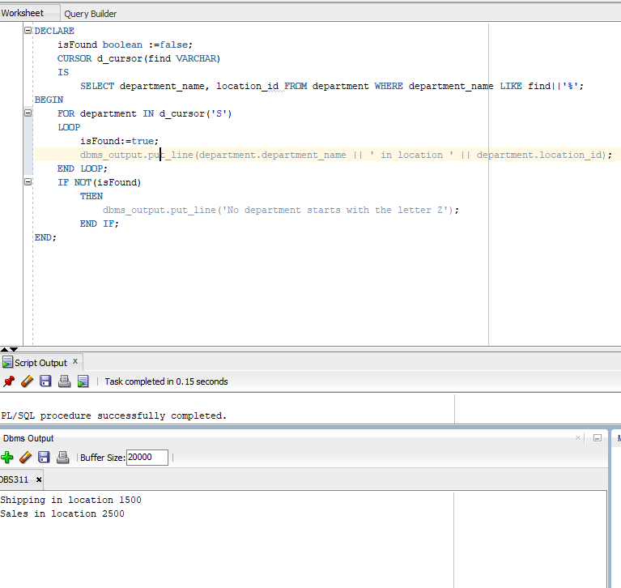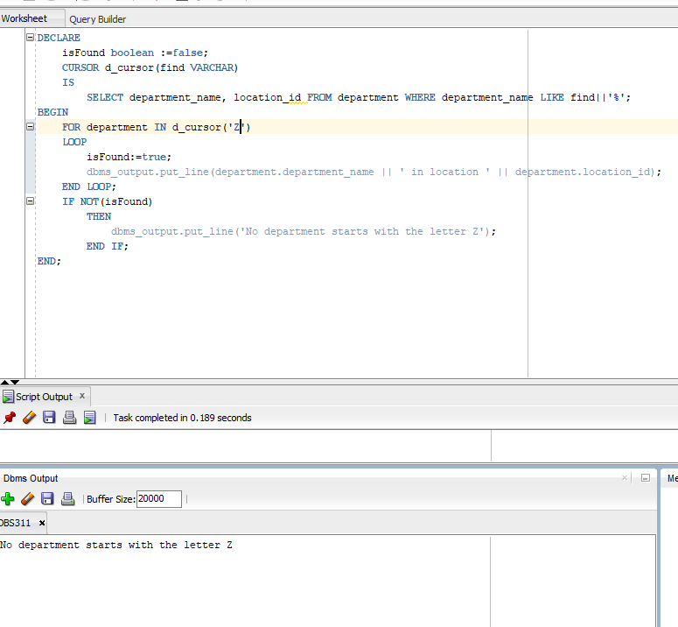

3.

create or replace PROCEDURE SHOW_DEPARTMENT_BY_CHARACTER(search VARCHAR)

IS

CURSOR d_cursor

IS

SELECT department_name, location_id FROM department WHERE department_name LIKE search||'%';

isFound boolean :=false;

BEGIN

FOR department IN d_cursor

LOOP

isFound:=true;

dbms_output.put_line(department.department_name || ' in location ' || department.location_id);

END LOOP;

IF NOT(isFound)

THEN

dbms_output.put_line('No department starts with the letter '||search);

END IF;

END SHOW_DEPARTMENT_BY_CHARACTER;

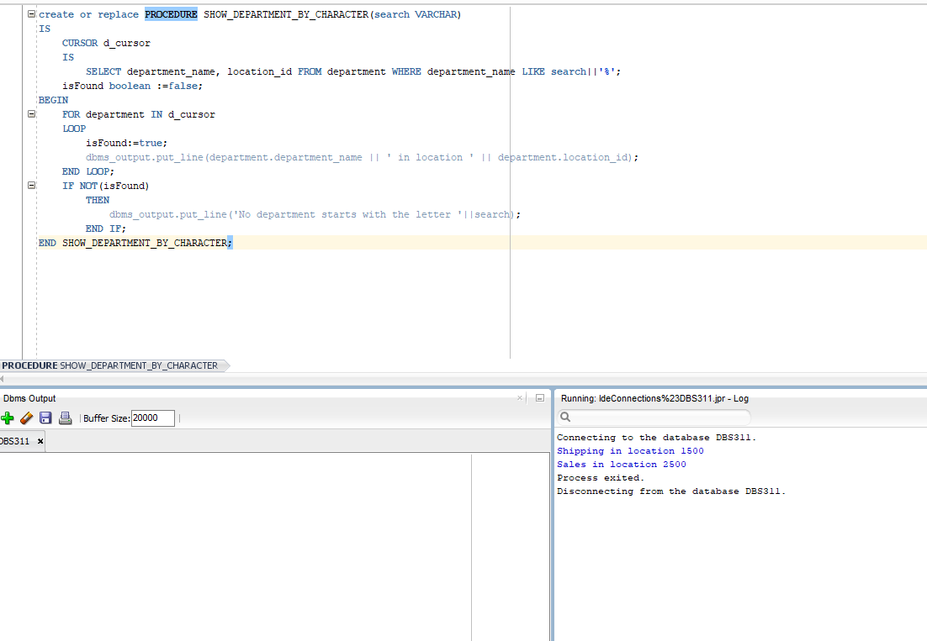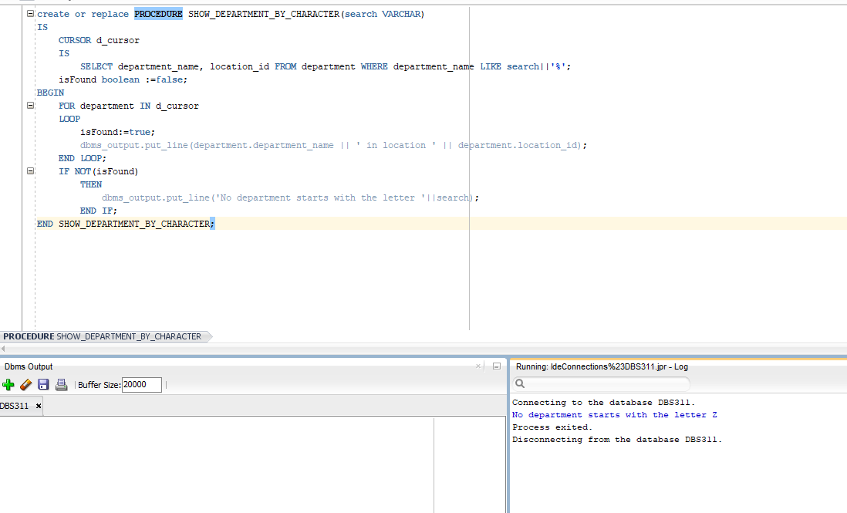4.

DECLARE

l_city location.city%type;

d_name department.department_name%TYPE;

d_managerid department.manager_id%TYPE;

status VARCHAR(45);

CURSOR find_city_cursor(search VARCHAR)

IS

SELECT department_name, city, manager_id FROM location LEFT JOIN department USING(location_id) WHERE city LIKE search||'%' ORDER BY department_name;

BEGIN

OPEN find_city_cursor('T');

LOOP

FETCH find_city_cursor INTO d_name, l_city, d_managerid;

EXIT WHEN find_city_cursor%notfound;

IF(d_managerid >= 100 AND d_managerid <= 200)

THEN

status:='managed by one of the Senior Managers.';

ELSE

IF(d_managerid IS NULL)

THEN

status:='without manager.';

ELSE

status:='NOT managed by one of the Senior Managers.';

END IF;

END IF;

IF(d_name IS NOT NULL)

THEN

dbms_output.put_line('Department '||d_name||' in a city named '||l_city||' is '||status);

dbms_output.put_line('');

ELSE

dbms_output.put_line('There is NO Department in a city named '||l_city);

dbms_output.put_line('');

END IF;

END LOOP;

CLOSE find_city_cursor;

END;

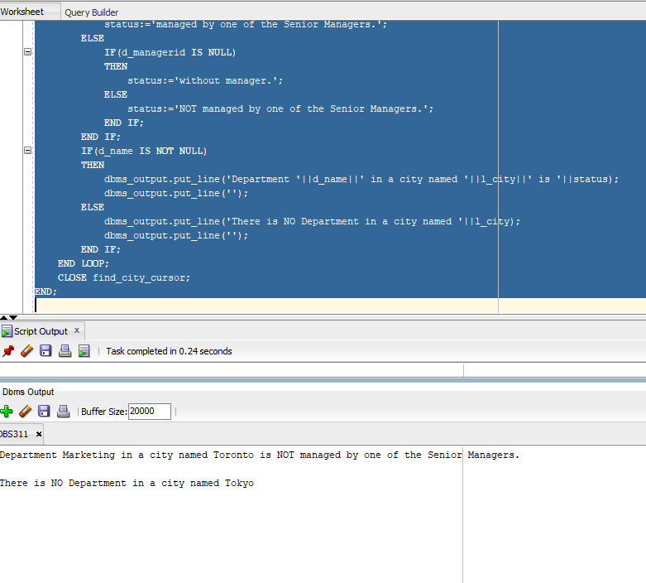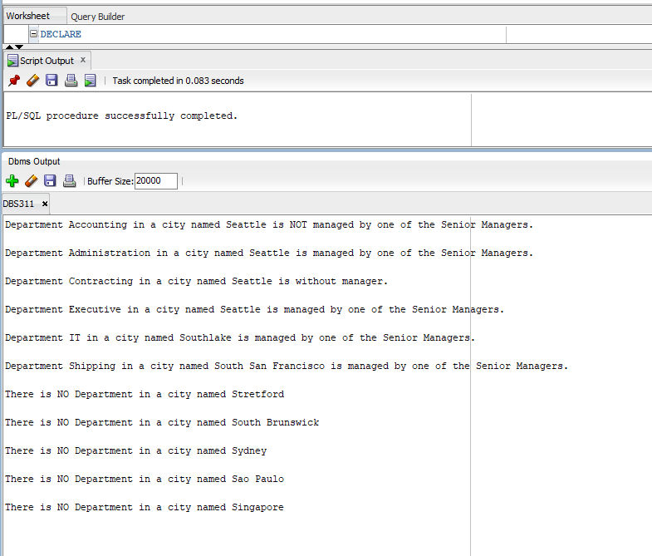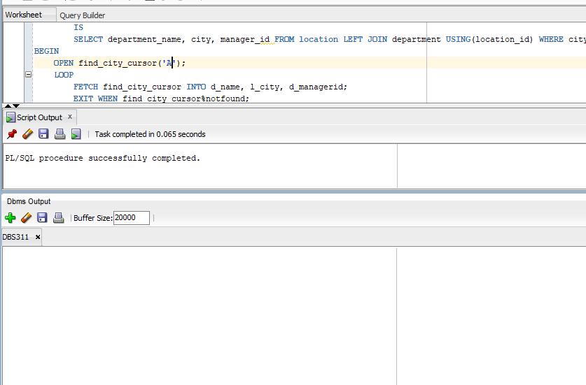

5.

create or replace PROCEDURE FIND_DEPARTMENT_BY_CITY(search VARCHAR)

IS

status VARCHAR(45);

CURSOR find_city_cursor

IS

SELECT department_name, city, manager_id FROM location LEFT JOIN department USING(location_id) WHERE city LIKE search||'%' ORDER BY department_name;

BEGIN

FOR city IN find_city_cursor

LOOP

IF(city.manager_id >= 100 AND city.manager_id <= 200)

THEN

status:='managed by one of the Senior Managers.';

ELSE

IF(city.manager_id IS NULL)

THEN

status:='without manager.';

ELSE

status:='NOT managed by one of the Senior Managers.';

END IF;

END IF;

IF(city.department_name IS NOT NULL)

THEN

dbms_output.put_line('Department '||city.department_name||' in a city named '||city.city||' is '||status);

dbms_output.put_line(' ');

ELSE

dbms_output.put_line('There is NO Department in a city named '||city.city);

dbms_output.put_line(' ');

END IF;

END LOOP;

END FIND_DEPARTMENT_BY_CITY;

